MARKING KEY

0000.doc

STAGE 3 COMPUTER SCIENCE EXAM MARKING GUIDE

SECTION 1—WRITTEN QUESTIONS

Question 1
You are developing a backup and recovery plan for a small business and have decided to investigate the option of Internet-based backup and archiving. Using such a service means that the business would send a copy of all its data files over the Internet for backup storage.

Apart from the cost, discuss two important factors that should be investigated before signing up for an Internet-based backup service.
[From: Victorian Curriculum and Assessment Authority, 2005]

Description | Mark
the method of obtaining data via the Internet—the data should be encrypted to protect it during transmission | 1
the security of guest data—as guests provide personal details, including their credit card numbers, the business must be able to guarantee that it is not being accessed by others while at the backup site | 1

Question 2
A user has reported that nothing appears on the screen when they type on the computer keyboard. Describe what you would do to determine if the keyboard is the problem.

Description | Mark
- Take a keyboard known to be functioning correctly (one that is working with another computer) and replace the faulty one  - Check to see that the new keyboard works with this computer  - If not there may be something wrong the port to which the keyboard is attached so try another port if the keyboard has a USB connection  - If it still doesn’t work there’s probably a problem with the computer rather than the keyboard | [1 mark for a good description of the process]

Question 3
(a) What does a modem do?

Description | Mark
A modem converts computer signals/data into a format (typically analogue to digital) that can be transmitted through the public telephone network. It also receives signals/data from the phone network and converts it into a format (typically digital to analogue) that can used by the computer. | 1

(b) Describe how a router can help make a large network run more efficiently.
[From: Victorian Curriculum and Assessment Authority, 2006]

Description | Mark
A router makes a large network run faster by only sending data to the appropriate network or subnet that requires it. By sending data to the subnet that requires it, rather then every connected subnet, the total data sent is considerably less and so speed increases. | 1

Question 4
A network operating system can provide administrators with the ability to control levels of access to the file server. Outline why an administrator would make use of this capability.
[From: Victorian Curriculum and Assessment Authority, 2005

Description | Mark
- to limit user access to data—different types of users may need different privileges such as delete, creating folders etc  - to assign privileges such as installing or uninstalling software | 1  (for a valid use with some explanation)

Question 5
Using an example of a device that uses an embedded operating system explain how an embedded operating system differs from an operating system found on a personal computer such as Windows or Mac OS.

Description | Mark
An embedded operating system is found on devices such as PDAs and mobile phones. These operating systems are designed to be very compact and efficient, and do not include many functions that traditional operating systems such as Windows provide. They are specialised purpose operating systems and don’t require the more general purpose functions provided by Windows.  There are many devices that could be mentioned—key difference is that embedded operating systems are limited and have specialised functions. | 2

Question 6
A payroll system could be implemented as either a real-time or batch transaction processing system.

(a) Explain how a transaction would be processed in a real-time system.
Description | Mark
A transaction is entered at a terminal and the system must responded within a short period of time. Each transaction must be complete before the next one is processed. A payroll system enquiry must quickly look up a pay rate or allow an employee’s hours worked to be processed and stored. | 1

(b) Explain why a batch transaction processing system is appropriate for a payroll system.
Description | Mark
Batch processing is the execution of a series of programs on a computer without human interaction, when possible. As payroll processing is typically done once a week, fortnight or month and because it does not rely on interactive processing it can be run using batch processing after hours when the computer system is less busy. | 1

Question 7
To successfully network computers a protocol must be used. Explain how a protocol makes networking possible.
[From: Victorian Curriculum and Assessment Authority, 2005

Description | Mark
A protocol is the set of rules needed so that computers can talk to one another. Without a set of rules, and computers conforming them, computers would not be able to talk to each other. | 1

Question 8
(a) Explain the difference between data mining and a data warehouse.
Description | Mark
A data warehouse is a repository for a company’s historical data. The data is usually about a subject, for example sales data. It contains date information that can be used for searching. The data is organised so that it can be easily searched by people within the organisation.  Data mining is a process used to extract information from large data sets. Typically this is ‘patterns’ in the data that were previously not known. Classic example is men buying nappies and beer at the same time on their way home. | 1

(b) Explain how data mining can be used in conjunction with a data warehouse.
Description | Mark
A data warehouse usually provides the data that is used by the data mining process to be able to find the patterns it is searching for. | 1

Question 9
A packet sniffer, also known as a network monitor or network analyser, captures all the packets of data that pass through a given network interface.
(a) Describe one valid reason for using a packet sniffer.

Description | Mark
A packet sniffer could be used by a network administrator to investigate why there are errors in a network. | 1

(b) Describe one inappropriate use for a packet sniffer.

Description | Mark
A hacker or criminal could use a packet sniffer to discover someone’s private information, for example credit card details. | 1

(c) Explain how encryption can be used to protect against packet sniffers.

Description | Mark
Encrypting the data in packets can protect against illegal reading of the data. | 1

Question 10
Complete the statements following with the appropriate term from this list.
- system support documentation
- parallel conversion
- cost
- usability
- partial conversion
- project management
- testing techniques
- database modelling
i. ___________________ could be tested when evaluating the performance of a system.
ii. ___________________ is used to monitor tasks and assign resources.
iii. ___________________ is a method used when implementing a new system.
iv. ___________________ is used when designing a new system.
[Adapted from: Victorian Curriculum and Assessment Authority, 2005]

(i) could be tested when evaluating the performance of a system.

Description | Mark
usability | ½

(ii) is used to monitor tasks and assign resources.

Description | Mark
project management | ½

(iii) is a method used when implementing a new system.

Description | Mark
parallel conversion | ½

(iv) is used when designing a new system.

Description | Mark
database modelling | ½

Question 11
Briefly explain the use of the Rapid Application Development (RAD) method when developing systems.
[From: Victorian Curriculum and Assessment Authority, 2007]
Description | Mark
Rapid application development (RAD), is a software development process that involves iterative development, the construction of prototypes, and the use of Computer-aided software engineering (CASE) tools. | 1

Question 12
A company located in a Bunbury, a large West Australian regional town wants to set up a global online purchasing website. A local Internet service provider (ISP) can host this website for $40 per month. Another ISP, located in India, is offering a similar service for $30 per month.
Outline two factors that should be considered before an ISP is selected.
[From: Victorian Curriculum and Assessment Authority, 2005]
Description | Mark
- economic—how much will the service actually cost, are there going to be costs associated with downloading internationally rather than from a local ISP  - social—local employment opportunities, importing expertise  - technical—availability of technical support  - location in itself is not a factor unless it is related to services that couldn’t be performed due to location, such as on-site technical support | 1 for each of two factors with some explanation

Question 13
The following statements are contained in a large insurance company’s privacy document which is sent to all clients annually when they are sent a bill to renew their policy.
YOUR PERSONAL INFORMATION
Personal information held by us may include your name and contact details which are collected by us so we can contact you.
DISCLOSURE OF YOUR PERSONAL INFORMATION
We rely on third party suppliers (agents, legal advisers, other insurance companies and mailhouses) to perform specialised activities for us.
Your personal information may be provided to them so that they may carry out their agreed activities.
Explain, in relation to privacy legislation, why the document is sent to clients and the reasons for including the above statements.
[From: Victorian Curriculum and Assessment Authority, 2005]

Description | Mark
Why sent - Privacy legislation requires that the client be informed of how the organisation uses the data they collect. The document provides the client with this information.  The first statement is included to inform the client how personal details are used within the organisation, which is required by the legislation.  The second statement is included to inform the client that their personal details will be provided to other parties and identifies these parties so that the client is informed about the use of data collected. | 1  1  1

Question 14
[From: Victorian Curriculum and Assessment Authority, 2006]

Swap Songs with Strangers

For copyright reasons this excerpt cannot be reproduced in the online version of this document, but may be viewed at http://technology.newscientist.com/channel/tech/mg18925335.300-mp3-players-swap-songs-with-strangers.html.

Excerpt from New Scientist p. 19, 7 January 2006

(a) If the Australian Government allowed this new software package to be used, identify the legislation that would be breached.

Description | Mark
Copyright Amendment (Digital Agenda) Act 2000. Accept anything abut copyright. | 1

(b) Identify and explain one ethical issue associated with using this new software package.

Description | Mark
You must purchase a legitimate copy of a song before you can store it on a digital medium (so that the writer/creator obtains their royalty fee).  The copyright owner controls when and how electronic communication of the work can occur (this software package sends the music without consent). | 1

Question 15
Explain why large organisations use RAID storage for their data.

Description | Mark
RAID, meaning Redundant Array of Independent (or Inexpensive) Disks, is when two or more disks are used to store data so that there is always more than one copy of any piece of data. Hence if one copy of data is lost the spare copy (or copies) can be used. Since the data in an organization can be very important to the organization, either from a strategic point of view or else for government regulations and requirements, it is important that a system such as RAID is used for organizational data. | 1

Question 16
Explain how the following are used in structured programming. Do not just define the terms.

Description | Mark
- stub  A stub is a piece of code used to stand in for some other programming functionality. A stub may simulate the behavior of existing code or be a temporary substitute for yet-to-be-developed code.  - parameter  A parameter is a variable which takes on the value of the corresponding argument passed in the call to a procedure. Within a procedure the parameters act as local copies of the argument. Parameters are used to pass values to and from procedures. | 1  1

Question 17
An electronic customer file is currently organised in the following way

Customer | Address | Phone | Pet 1 | Pet 2 | Pet 3
Jan Appleby | 35 Smith St West Perth | 9298 3467 | Ebony
Bill Owen | 14 Railway Pde Bayswater | 08 9453 4563 | Flossie | Fido | Tweety
Kim Anderson | 215 Barnes Ave Cottesloe | 9313 1329 | Bessie | Molly

- Suggest two changes to the design that would make this table more efficient for staff wanting to look up customer details.
[From: Victorian Curriculum and Assessment Authority, 2005]
Description | Mark
Format the phone number.  Split up the address into parts; street, suburb.  Split up the customer name into first and second name.  Take out the Pets as a separate table. | 2

- Normalise the data in this table to 3NF (Third Normal Form)

Description | Mark
CUSTOMER(CustID, CustSurname, CustFirstName, CustAddress, CustSuburb, CustPhone)  PET(PetID, PetName, CustID(fk))  Primary keys underlined.  Foreign keys (fk) | 2

Question 18
Consider the Australian library portal shown below:

Using examples from the portal shown above, explain two advantages of using a portal.

Description | Mark
A portal is a convenient way to display different ways of accessing a large amount of data (and/or processes) in a simple to access way. For example, on the portal there are many ways to access the different resources the library provides. For example, the link to the catalogue or the search, or Ask Now.  The portal can also contain information about how to find things on the portal. For example the FAQ link. | 2

Question 19
[From: Board of Studies New South Wales, 2006]

Consider a database which keeps track of geographical information – countries and their capitals, continents, oceans, mountains and rivers. Construct an Entity Relationship Diagram (ERD) for this database taking into consideration the following information:
  - Each country has a name, population, capital and exists on one continent.
  - Each continent has a name, size and contains one or more countries. One or more oceans border each continent.
  - Each ocean has a name, size and maximum known depth. An ocean borders one or more continents
  - Each mountain has a name, height and exists in only one country.
  - Each river has a name and length and flows through one continent to a single ocean
(a) Draw an E-R diagram to represent the database design. Show all tables and their attributes (primary and foreign keys and non-key attributes) and underline the primary keys. Mark the foreign keys with the code ‘fk’.

continent_name
size
Country
country_name
population
capital
fk continent_name
exists on
Continent
M
1
Ocean Continent
continent_name
ocean_name
Ocean
ocean_name
ocean_size
max_depth
borders
1
M
has
M
1
has
M
1
Mountain
mountain_name
height
fk country_name

River
has
1
M
river_name
length
continent_name fk
ocean_name fk

has
M
1

[1 mark per entity with correct attributes, primary keys and foreign key and relationships
deduct ½ mark per incorrect relationship]
6 marks
The data dictionary shown below was developed to show users the fields to be included in the table called ‘Country’.

Field name | Type | Length | Description
CountryName | Text | 25 | Name of the country
Continent | Text | 15 | Continent in which the country is situated
BirthRate | Text | 6 | Percentage value of the birth rate in the country
DeathRate | Text | 6 | Percentage value of the death rate in the country
LifeExpectancy | Text | 6 | Expected life span of the male population
Language | Text | 10 | Language spoken by most of the population

(b) Using the data dictionary, construct an SQL command that would display the names of countries in the continent of South America where most of the population speak Spanish.

Description | Mark
- SELECT CountryName  - FROM Country  - WHERE Continent = ‘South America’ AND  - Language = ‘Spanish’ | 2

(c) After seeing the data dictionary, a user would like to be able to:
- calculate the rate of population increase using the fields BirthRate and DeathRate;
- store information about the expected life span of the female population.

Explain the changes that would have to be made to the data dictionary to best meet the user’s needs.

Description | Mark
- BirthRate and DeathRate would have to be made numeric fields.  - Would need to have the population of the country.  Would need LifeExpectancy for the female population to be added. | 3

Question 20
Lucy has decided she needs some help to introduce her new computer climate control system for her greenhouses. She employs a system analyst, Susan, and outlines her current system and what she would like to achieve with the new system.
Susan has discovered a shareware program on the Internet that appears to suit Lucy’s needs. The program uses a number of standard interface screens that will allow Lucy to make adjustments to the conditions in the greenhouses. Other screens are used to alert Lucy to problems in the greenhouses.
The following screen is a typical data entry screen.

- Lucy thinks that this screen has a major design fault. Identify this fault and suggest how the fault can be corrected.

Description | Mark
The screen has no indication where to put the upper or lower limits  The screen doesn’t mention the units used  The appropriate corrections could include ‘add the words minimum and maximum above the boxes’, or ‘add the units after each box; for example, ºC after each white box, next to temperature’. | 1

Lucy has decided against the shareware program and buys the Dutch software. After installing it, her friend Peter, who is a programmer, is convinced that the Dutch software has some major faults. He has offered to fix these problems for Lucy, free of charge.

- Explain one legal obligation and one ethical consideration that Lucy should think about before she accepts or rejects Peter’s offer to alter the program code.

Description | Mark
Before Lucy allows this to happen she should check her licence requirements for the software. As Peter is not charging for the software or trying to sell it again, he is not breaking any legal or ethical considerations in this area.  Legal  - Some software specifically prohibits it from being edited by other programmers. Lucy would need to see if it can be edited to make sure it is legal.  Ethical  - Ethically, Lucy can not redistribute or sell the altered software.  - Other considerations might be:  - is the code open source?  - will the company support Lucy after the alterations have been made  - current copyright legislation | 1  1

Susan has created a PERT chart to help manage the project. A section of the chart is shown below.
(c) Use this chart to answer the following:
(i) Identify two tasks that can be performed at the same time.

Description | Mark
Either of:  - ‘write code’ and ‘create test data’  - ‘document module’ and ‘test module’ | 1

(ii) What is the minimum number of days that this section of the project can be completed in?

Description | Mark
5.5 days | 1

[From: Victorian Curriculum and Assessment Authority, 2005]

(d) The new system requires a computer in each nursery to control the greenhouse climates. The orchids may be damaged if these computers fail to work. Each computer will be placed in a small enclosed area as shown in Proposed plan for the two nurseries.

List one hazard to which these computers will be exposed and describe how Lucy should protect the computers from this hazard.

Description | Mark
Hazards could include:  - power failure  - theft/vandalism  - computer failure  - environmental factors – heat, humidity, water, dirt, etc.  Protection - a secure, air conditioned enclosure is required to protect the computer from theft, water, heat, etc. | 1

(e) Lucy wishes to connect a computer in her local nursery with a computer in her house so she can monitor the greenhouse from her study. The distance is approximately 30 metres. She has two choices:

- Option 1: to connect via CAT-5 cable
- Option 2: to set up a wireless link

Select the better option for Lucy. Justify your selection by comparing the two options.
Solution | Mark
If CAT 5 is chosen, justifications could include:  - this is a more secure option between the shed and the house, as wireless connections are more susceptible to security breaks  - cable is cheaper, however the installation across the 30 metres between the shed and the house would add an extra cost.  If wireless is chosen, justifications could include:  - this is the simplest option to install as there would be no trenches to dig to lay cables.  - this is the more flexible option as it would mean that Sam could have his house computer anywhere he wants, whereas using cabling means that the connecting points for the computer would need to be hard wired. | 1–2  (1 if answer doesn’t compare the two; 2 for an answer with justification comparing the two options)

(f) Over the last five years Lucy and a team of researchers from the University of Western Australia have been experimenting with hybrid orchids attempting to develop new flower colours.

Susan’s level 1 data flow diagram represents the recording and analysing of research data that she has observed and is described below.

Experimenters record flower colours for new hybrids using handwritten tally sheets. After observations have been completed, each of the experimenters keys in tally totals on the computer in the green house for later analysis.

At the end of each day, Lucy runs a program that uses the colour tally totals and the hybrid flower details from the hybrid master file to create a daily experiment report. An electronic copy of the report is stored in the Daily reports file.

Similar experiments are being conducted at two other nurseries, The Orchid Place in Singapore and Paradise Orchids in Taiwan. The results from these sites are emailed to Lucy once a week. Lucy runs a program to enter the overseas hybrid flower results into the hybrid master file. When all the overseas results have been entered Lucy uses the program to calculate statistics for the week’s experiments. These statistics are saved in the Hybrid master file. The word processed hybrid colour weekly report is then prepared by including the statistics from the Hybrid master file and comments that Lucy adds. This report is emailed to the researchers at UWA.

[Adapted from: Victorian Curriculum and Assessment Authority, 2006]

Draw a level 2 data flow diagram to expand process 3.

Solution | Marks
3.1  Enter overseas details  3.2  Prepare  report  statistics  3.3  Produce  weekly report  Hybrid master file  Singapore weekly colour tallies  Taiwan weekly colour tallies  overseas flower details  hybrid flower details  hybrid colour weekly results  hybrid flower statistics  hybrid flower statistics | ½ mark for each process, file and vector (up to 5 marks)  1 for not including external entities
Section 2—Computer-based questions

PART A—DATABASE QUESTIONS

Question 21
The Astro Hockey Club Database
The Astro Hockey Club wants to record details about teams and the equipment kits they have been allocated for the season.

Open the database file AstroHockey.mdb
Using the tables (see below) in the AstroHockey.mdb database complete the following tasks:

tblCoaches
CoachID | Surname | Firstname | Street | Suburb | Postcode | fCoachRating
1 | Cropper | John | 911 Millgate Road | SPORTSVILLE | 6108
2 | Eggleston | George | 6 Stedman Street | CROSSPATCH | 6149
3 | Green | Hannah | 117 Stanley Loop | KINGSTON | 6009
4 | Hill | John | 316 Gratwick Drive | SPORTSVILLE | 6108
5 | Jones | Margaret | 910 Downsborough Street | KEWDALE | 6105
6 | Mackrie | James | 516 First Ave | CLIFTON BEACH | 6076
7 | Morley | Joseph | 915 Voyager Way | SPORTSVILLE | 6108
8 | Parry | Sarah | 5 Grigo Ave | SPRINGVALE | 6169
9 | Richardson | James | 914 Carlow Circle | WILBURY | 6152
10 | Smith | Thomas | 6 Samson Drive | FRAMTON | 6160
11 | Todd | Nicholas | 917 Carissa Court | MERRIVALE | 6058

tblEquipAllocations
KitAllocationID | fTeamID | fEquipKitID | DateTaken | DateReturned | Deposit
1 | 1 | 1 | 8/04/2001 | 31/05/2001 | 15
2 | 1 | 6 | 19/04/2001 | 31/05/2001 | 15
3 | 3 | 5 | 8/04/2001 | 10/04/2001 | 30
4 | 4 | 2 | 9/04/2001 |  | 15
5 | 4 | 7 | 27/04/2001 |  | 15
6 | 6 | 1 | 3/06/2001 |  | 15
7 | 3 | 5 | 6/05/2001 | 7/05/2001 | 30
8 | 2 | 7 | 12/05/2001 | 13/05/2001 | 15
9 | 2 | 3 | 13/05/2001 | 15/05/2001 | 15

tblEquipKits
EquipKitID | Kit Code | Description | SuggestedDeposit
1 | JSS01 | Junior Stick Set 1 | 15
2 | JSS02 | Junior Stick Set 2 | 15
3 | JSS03 | Junior Stick Set 3 | 15
4 | SSS01 | Senior Stick Set 1 | 30
5 | SSS02 | Senior Stick Set 2 | 30
6 | JGG01 | Junior Goalie Gear 1 | 15
7 | JGG02 | Junior Goalie Gear 2 | 15

tblManagerAllocations
ManagerAllocationID | fTeamID | fManagerID | Season | DateStarted | DateEnded
1 | 1 | 1 | Winter 2001 | 1/04/2001
2 | 2 | 2 | Winter 2001 | 1/04/2001
3 | 3 | 3 | Winter 2001 | 1/04/2001
4 | 4 | 4 | Winter 2001 | 1/04/2001
5 | 5 | 5 | Winter 2001 | 12/04/2001
6 | 6 | 1 | Winter 2001 | 15/04/2001

tblManagers
ManagerID | Surname | Firstname | Phone
1 | Jones | Sue | 9376 1234
2 | Wright | Andrew | 9275 1588
3 | Case | Bob | 9477 7631
4 | Green | Michael | 9578 9012
5 | Pearson | Jill | 9475 3198
6 | Jones | Sue | 9376 1234

tblTeams
TeamID | TeamName
1 | Bulldogs Boys U12A
2 | Jets Boys U12B
3 | Tigers Vets
4 | Apollo Girls U12C
5 | Jets Girls U14A
6 | Bulldogs Boys U14B

Question 21
- Create the necessary relationships between the six tables provided. You may need to create an additional table. Be sure to enforce referential integrity for each relationship.

Description | Mark
tblManagers to tblManagerAllocations  tblManagerAllocations to tblTeams  tblTeams to tblEquipAllocations  tblEquipAllocations to tblEquipKits  creation of table tblCoachAllocations (PK & FKs)  tblTeams to tblCoachAllocations  tblCoachAllocations to tblCoaches | ½  ½  ½  ½  2  ½  ½
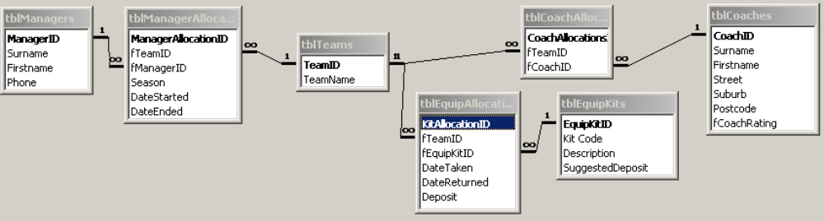

- (i) Open the table tblEquipKits.
  - Create a rule to ensure that the SuggestedDeposit must be greater than zero.

Description | Mark
Validation rule > 0  Validation text “Your deposit must be greater than 0” | 1

  - The SuggestedDeposit field utilises the data type Number – Byte. Choose a more appropriate data type for this field.
Description | Mark
Field data type as currency  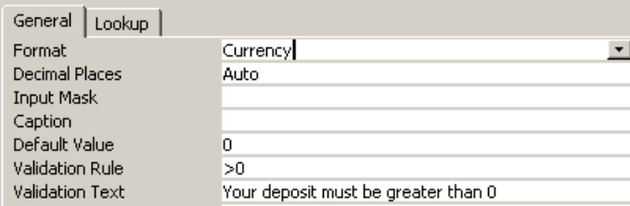 | ½

Save and close the table tblEquipKits.

(ii) Open the table tblEquipAllocations.
- Change the fTeamID field to a lookup field that displays a combo box with the source tblTeams. Set the properties so that the name of the team is displayed when the table is viewed in datasheet view.

Description | Mark
Combo Box row source is tblTeams  Column Count 2 and Column 1 width set to 0 | ½  1
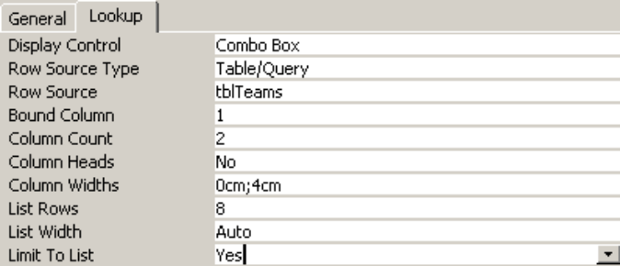

- Make similar changes to the fEquipKitID field.

Description | Mark
Combo Box row source is tblEquipKits  Column Count 2 and Column 1 width set to 0 | 1  1
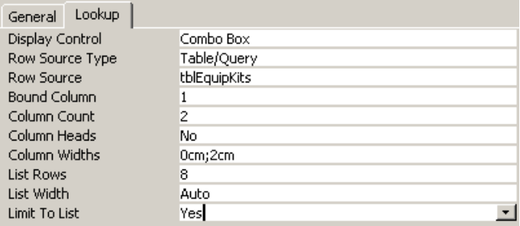

Save and close the table tblEquipAllocations.
Question 22
The Astro Hockey Club Database
Create the following queries in the Astro Hockey Club database.

- A query that lists the Firstname, Surname and Suburb of all coaches who have a postcode beginning with 61. Sort the Surname field alphabetically.

Save the query as qryPostcode

Description | Mark
Criteria: Like “60*”  Surname sorted ascending | ½  ½
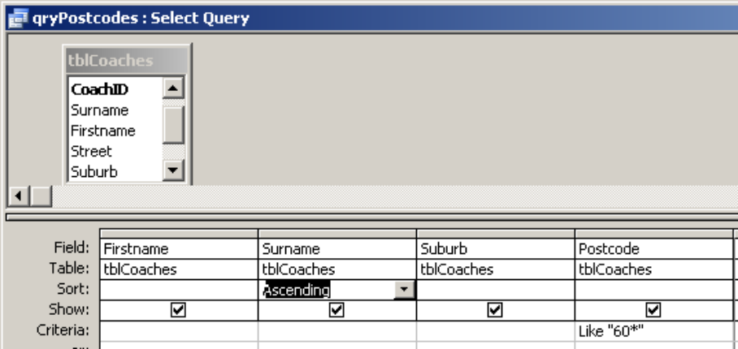

- A query that lists the manager phone numbers and names in a combined field called Fullname (eg John Smith).

Save the query as qryFullname

Description |  | Mark
Field definition: Fullname:  [Firstname] & " " & [Surname |  | ½  1½
Design view  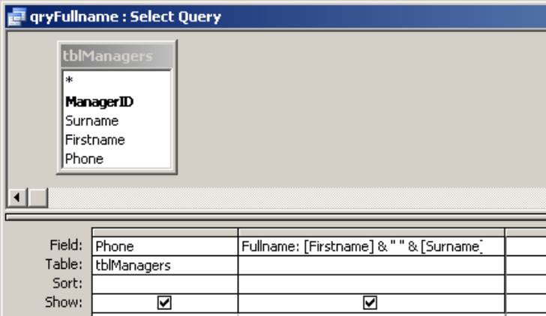 | Datasheet view
  qryFullname
  Phone | Fullname
  9376 1234 | Sue Jones
  9275 1588 | Andrew Wright
  9477 7631 | Bob Case
  9578 9012 | Michael Green
  9475 3198 | Jill Pearson
  9376 1234 | Sue Jones

- An update query that increases the SuggestedDeposit in tblEquipKits by $5.

Save the query as qryIncreaseDeposit

Description | Mark
Append query selected  Update to: [SuggestedDeposit]+5 | ½  ½
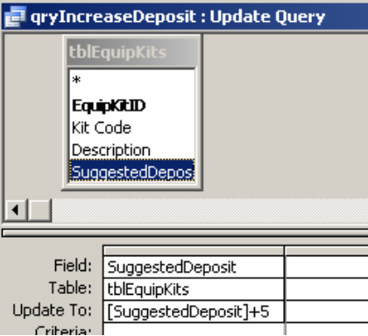

- A delete query that will delete the coaches who live in Sportsville from tblCoaches.

Save the query as qryDeleteCoaches

Description | Mark
Delete query selected  Delete criteria: Sportsville | ½  ½
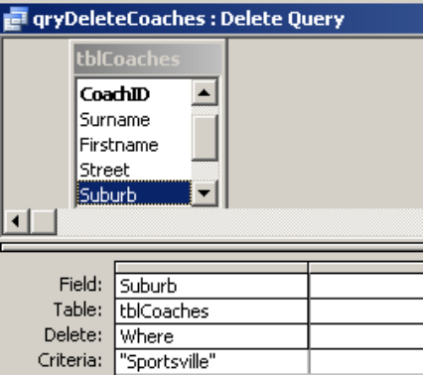

- A query that shows the kit code, description and date taken of all equipment kits that have not been returned.

Save the query as qryEquipNotReturned

Description | Mark
Both tblEquipKits and tblEquipAllocations  Date returned criteria: Is Null | 1  1
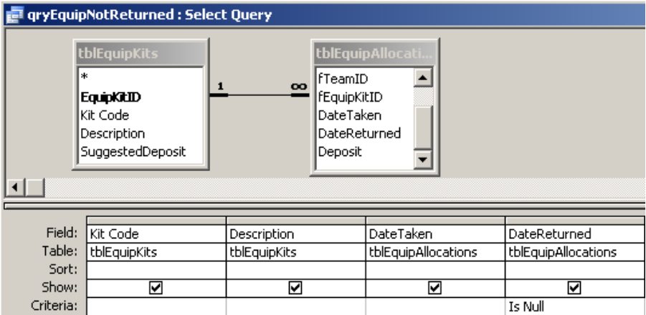

- A parameter query that prompts the user to enter a start date and a finish date for the DateTaken in tblEquipAllocations. Show the TeamName, KitCode, Description, DateTaken and Deposit of all equipment kits taken within the date range.

Save the query as qryEquipDateRange

Description | Mark
3 tables and required fields  Use of between or greater than and less than  Parameter for start date  Parameter for finish date | 1½  ½  ½  ½
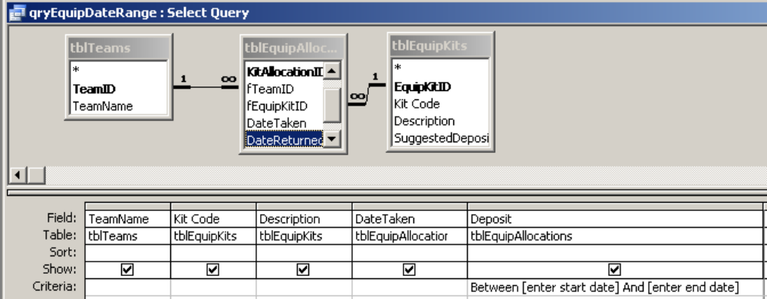

Part B-Programming questions

Question 23
- Study the algorithm and read the comments in the code module to determine how the module functions. Good modular programming practice ensures that
- a module performs a single task
- parameters are used to pass data in and out of modules

Improve this program by dividing this module into a series of modules. Use the current existing module to call the other modules and for user input and output.

Description | Mark
Correct Parameters used: Handling - NetPrice and Handling  Stamp Duty - NetPrice and SubTotal  GST - SubTotal and GrossPrice  Bonus – GrossPrice  Correct breakdown into: Handling, Stamp Duty, GST and Bonus modules  Program 2 operates the same as Program 1  NetPrice (ByValue), HandlingFee (By Reference) | 4  4  2  2

- A function is a special type of module that returns a single value. Create a function to calculate the final amount owed after a trade-in vehicle value is typed in by the user. The amount should be calculated after the GST is calculated.

Modify the existing code to make use of this function.

Description | Mark
Correct module (function) and parameters  Correct implementation | 2  2

Question 24
Write the code for a program that will store the numbers 1 to 10 in an array called Numlist. The program should output these numbers in reverse order, from 10 down to 1.

Description | Mark
Array declaration  Array initialisation  Reverse output  Dim NumList(1 To 10) As Integer  Dim Count As Integer  For Count = 1 To 10  NumList(Count) = Count  Next Count  For Count = 10 To 1 Step -1  Print (NumList(Count)) | 1  1  2

ACKNOWLEDGEMENTS

Question 1: Adapted from: Victorian Curriculum and Assessment Authority. (2005). Information Systems: Written examination: Victorian Certificate of Education 2005 (p. 20). Retrieved August, 2007, from http://www.vcaa.vic.edu.au/vce/studies/infotech/infosystems/pastexams/2005infosys.pdf.
© VCAA

Question 3b: Victorian Curriculum and Assessment Authority. (2006). Information Systems: Written examination: Victorian Certificate of Education 2006 (p. 6). Retrieved August, 2007, from http://www.vcaa.vic.edu.au/vce/studies/infotech/infosystems/pastexams/2006infosys-w.pdf.
© VCAA

Question 4: Victorian Curriculum and Assessment Authority. (2005). Information Systems: Written examination: Victorian Certificate of Education 2005 (p. 4). Retrieved August, 2007, from http://www.vcaa.vic.edu.au/vce/studies/infotech/infosystems/pastexams/2005infosys.pdf.
© VCAA

Question 7: Adapted from: Victorian Curriculum and Assessment Authority. (2005). Information Systems: Written examination: Victorian Certificate of Education 2005 (p. 5). Retrieved August, 2007, from http://www.vcaa.vic.edu.au/vce/studies/infotech/infosystems/pastexams/2005infosys.pdf.
© VCAA

Question 10: Adapted from: Victorian Curriculum and Assessment Authority. (2005). Information Systems: Written examination: Victorian Certificate of Education 2005 (p. 2). Retrieved August, 2007, from http://www.vcaa.vic.edu.au/vce/studies/infotech/infosystems/pastexams/2005infosys.pdf.
© VCAA

Question 11: Victorian Curriculum and Assessment Authority. (2007). Information Technology: Software Development 2007–2010: Written examination—end of year (p. 11). Retrieved August, 2007, from http://www.vcaa.vic.edu.au/vce/studies/infotech/softwaredevel/2007_softwaredev_sample.pdf.
© VCAA

Question 12: Adapted from: Victorian Curriculum and Assessment Authority. (2005). Information Systems: Written examination: Victorian Certificate of Education 2005 (p. 3). Retrieved August, 2007, from http://www.vcaa.vic.edu.au/vce/studies/infotech/infosystems/pastexams/2005infosys.pdf.
© VCAA

Question 13: Victorian Curriculum and Assessment Authority. (2005). Information Processing and Management: Written examination: Victorian Certificate of Education 2005 (p. 13). Retrieved August, 2007, from http://www.vcaa.vic.edu.au/vce/studies/infotech/infoprocess/pastexams/2005ipm.pdf.
© VCAA
Question 14: MP3 players swap songs with strangers. (2006, January 7). New Scientist, 2533.

Victorian Curriculum and Assessment Authority. (2006). Information Processing and Management: Written examination: Victorian Certificate of Education 2006 (p. 15). Retrieved August, 2007, from http://www.vcaa.vic.edu.au/vce/studies/infotech/infoprocess/pastexams/2006IPM-w.pdf.
© VCAA

Question 17: Adapted from: Victorian Curriculum and Assessment Authority. (2005). Information Processing and Management: Written examination: Victorian Certificate of Education 2005 (p. 8). Retrieved August, 2007, from http://www.vcaa.vic.edu.au/vce/studies/infotech/infoprocess/pastexams/2005ipm.pdf.
© VCAA

Question 19: Board of Studies New South Wales. (2006). Information Processes and Technology: 2006 Higher School Certificate Examination (p. 12). Retrieved August, 2007, from http://www.boardofstudies.nsw.edu.au/hsc_exams/hsc2006exams/pdf_doc/info_process_tech_06.pdf.

Question 20: Adapted from: Victorian Curriculum and Assessment Authority. (2006). Information Systems: Written examination: Victorian Certificate of Education 2006 (pp. 7, 10). Retrieved August, 2007, from http://www.vcaa.vic.edu.au/vce/studies/infotech/infosystems/pastexams/2006infosys-w.pdf.
© VCAA

Question 20c: Adapted from: Victorian Curriculum and Assessment Authority. (2005). Information Systems: Written examination: Victorian Certificate of Education 2005 (p. 5). Retrieved August, 2007, from http://www.vcaa.vic.edu.au/vce/studies/infotech/infosystems/pastexams/2005infosys.pdf.
© VCAA
Computer Science 3A / 3B Examination

 |  | Response |  | Written Component  60% |  |  | Computer Based Component 40%
 |  | 3A | 3B | 3A | 3B | Tot | 3A | 3B
Components  21% | Hardware  9% | Q1 Internet-based backup—2  Q2 Fault testing—1  Q20 (d) Hazard to hardware and what to do about it—1  Q15 RAID—1 | Q3 (a)Modem—1  Q3 (b) Router—1  Q20(e) Network media—2 | 5 | 4 | 9
Components  21% | Software  12% | Q4 Network Operating System—2  Q5 Embedded operating systems—2  Q6 (a) Real-time—1  Q6 (b) Batch processing system—1 | Q7 Network protocol—1  Q8 (a) Data mining  Q8 (b) Data warehouses—2  Q9 (a, b, c)  Sniffer software & encryption—3 | 6 | 6 | 12
Design, Development and management  19% | Systems  10% | Q10 SDLC key tasks—2  Q11 RAD—1  Q20 (c) Interpret PERT chart—2 | Q17 (a) Data Analysis—2  Q19 (c) Data Dictionary—3 | 5 | 5 | 10
Design, Development and management  19% | Ethics & law  9% | 20 (a) Interface evaluation—1  Q12 ISP Globalisation—2  Q20 (b) Modifying code—ethic/legal restrictions—2 | Q13 Privacy Act—2  Q14 Music piracy/copyright—2 | 5 | 4 | 9
Tools  60% | Data Rep | Q16 Structured programming—2  Q18 Portals/content management  systems —2 | Q19 (b) Querying DB—2  Q17 (b)Normalisation—2 | 4 | 4 | 8
Tools  60% | Sys Dev Tools | 20 Context Diagram/DFD—6 | Q19 (a) ERD—6 | 6 | 6 | 12 | Prog  20 | DB  20
TOTAL | 100% |  |  | 30 | 30 | 60 | 40

